Virtual Escapades Camp and Holiday
Online Activity Day
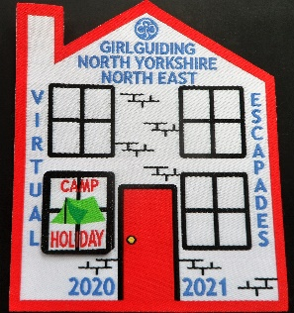
Virtual Escapades is our special badge to encourage virtual residential events to take place until we can return to face to face residential events.
You can find out all about the badge here:
Girlguiding NYNE Virtual Escapades Badge
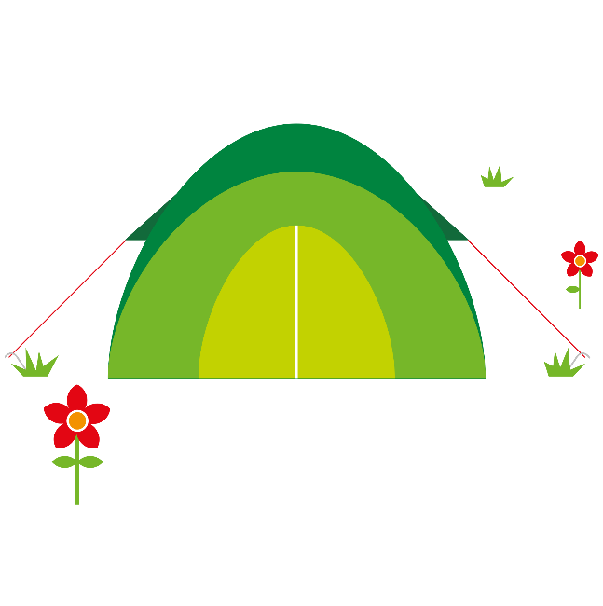
Has your daughter completed the camp and holiday window yet?
If not, why don’t they join us on Zoom and do everything needed to complete the window?

Saturday 5 June 2021
Rainbows and Brownies from 10.00 am - 12.00
Guides and Rangers from 1.00 pm - 3.00 pm

Please follow the appropriate link to register for a free place:
Rainbows and Brownies:
rainbow-and-brownie-virtual-escapades-activity-day-registration
Guides and Rangers:
guide-and-ranger-virtual-escapades-activity-day-registration
Registrations will close 22nd May

Badges will be available to order after the event:
The House badge – 50p each (you need one of these when you complete the first “window”)
The Camp and Holiday “window” badge – 50p each

If you have any questions, please contact: admin@girlguidingnyne.org.uk

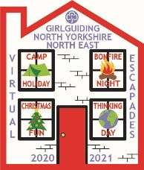
Look out for other opportunities to complete the other windows virtually throughout the rest of the year.

There is still time to get a full house!

